**ECONOMICS**

Table of Contents

Reading 14: Topics in demand and supply analysis 6

a. Calculate and interpret price, income and cross-price elasticities of demand and describe factors that affect each measure 6

b. Compare substitution and income effects 7

c. Distinguish between normal goods and inferior goods 7

d. Describe the phenomenon of diminishing marginal returns 8

e. Determine and interpret breakeven and shutdown points of production 8

f. Describe how economies of scale and diseconomies of scale affect costs 9

Reading 15: The firm and market structures 11

a. Describe characteristic of perfect competition, monopolistic competition, oligopoly and pure monopoly. 11

b. Explain relationships between price, marginal revenue, marginal cost, economic profit and the elasticity of demand under each market structure 12

d. Describe and determine the optimal price and output for firms under each market structure. 12

e. Explain factors affecting long run equilibrium under each market structure 12

g. Describe a firm’s supply function under each market structure 20

g. Describe pricing strategy under each market structure 20

g. Describe the use and limitations of concentration measures in identifying market structure 21

h. Identify the type of market structure within a firm operates 21

Reading 16: Aggregate output, prices and economic growth 22

a. Calculate and explain GDP using expenditure and income approaches 22

b. Compare the sum-of-value-added and value-of-final-output methods of calculating GDP 22

c. Compare nominal and real GDP and calculate and interpret the GDP deflator 22

d. Compare GDP, national income, personal income and personal disposable income 23

e. Explain the fundamental relationship among saving, investment, the fiscal balance and the trade balance 24

f. Explain the IS and LM curves and how they combine to generate the aggregate demand curve 25

g. Explain the aggregate supply curve in the short run and long run 27

h. Explain causes of movements along and shifts in aggregate demand and supply curves 28

i. Describe how fluctuations in aggregate demand and aggregate supply cause short run changes in the economy and the business cycle 29

j. Distinguish between the following types of macroeconomic equilibria: long run full employment, short run recessionary gap, short run inflationary gap and short run stagflation. 29

k. Explain how a short run macroeconomic equilibrium may occur at a level above or below full employment 29

l. Analyze the effect of combined changes in aggregate supply and demand on the economy 31

m. Describe sources, measurement and sustainability of economic growth 32

n. Describe the production function approach to analyzing the sources of economic growth 32

o. Distinguish between input growth and growth of total factor productivity as components of economic growth 33

Reading 17: Understanding Business Cycles 34

a. Describe the business cycle and its phases 34

b. Describe how resource use, housing sector activity, and external trade sector activity vary as an economy move through the business cycle 34

c. Describe theories of the business cycle 35

d. Describe types of unemployment and compare measures of unemployment 36

e. Explain inflation, hyperinflation, disinflation and deflation 37

f. Explain the construction of indexes used to measure inflation 37

g. Compare inflation measures, including their uses and limitations 37

h. Distinguish between cost-push and demand-pull inflation 38

i. Interpret a set of economic indicators and describe their uses and limitations 39

Reading 19: Monetary and Fiscal Policy 40

a. Compare monetary and fiscal policy 40

b. Describe functions and definitions of money 40

c. Explain the money creation process 41

d. Describe theories of the demand for and supply of money 42

e. Describe the fisher effect 43

f. Describe roles and objectives of central banks 44

g. Contrast the costs of expected and unexpected inflation 44

h. Describe tools used to implement monetary policy 44

i. Describe the monetary transmission mechanism 45

j. Describe qualities of effective central banks 45

k. Explain the relationships between monetary policy and economic growth, inflation, interest and exchange rates 45

l. Contrast the use of inflation, interest rate and exchange rate targeting by central banks 46

m. Determine whether a monetary policy is expansionary or contractionary 46

n. Describe limitations of monetary policy 47

o. Describe roles and objectives of fiscal policy 47

p. Describe tools of fiscal policy, including their advantages and disadvantages 47

q. Describe the arguments about whether the size of national debt relative to GDP matters 48

r. Explain the implementation of fiscal policy and difficulties of implementation 49

s. Determine whether a fiscal policy is expansionary or contractionary 49

t. Explain the interaction of monetary and fiscal policy 49

Reading 20: International trade and capital flows 51

a. Compare gross domestic product and gross national product 51

b. Describe benefits and costs of international trade 51

c. Distinguish between comparative advantage and absolute advantage 51

d. Compare the Ricardian and Heckscher-Ohlin models of trade and the sources of comparative advantage in each model 52

e. Compare types of trade and capital restrictions and their economic implications 52

f. Explain motivations for and advantages of trading blocs, common markets and economic unions 54

g. Describe common objectives of capital restrictions imposed by governments 55

h. Describe the balance of payments accounts including their components 55

i. Explain how decisions by consumers, firms and government affect the balance of payments 55

j. Describe functions and objectives of the international organizations that facilitate trade, including the World Bank, the IMF and the World Trade Organization 56

Reading 21: Currency Exchange Rates 58

a. Define an exchange rate and distinguish between nominal and real exchange rates and spot and forward exchange rates 58

b. Describe functions of and participants in the foreign exchange market 58

c. Calculate and interpret the percentage change in a currency relative to another currency 58

d. Calculate and interpret currency cross-rates 59

e. Convert forward quotations expressed on a points basis or in percentage terms into an outright forward quotation 59

f. Explain the arbitrage relationship between sport rates, forward rates and interest rates 59

g. Calculate and interpret a forward discount or premium 59

h. Calculate and interpret the forward rate consistent with the spot rate and the interest rate in each currency 60

i. Describe exchange rate regimes 60

j. Explain the effects of exchange rates on countries’ international trade and capital flows 61

# Reading 14: Topics in demand and supply analysis

## Calculate and interpret price, income and cross-price elasticities of demand and describe factors that affect each measure

**Own-price elasticity**

Own-price elasticity measures the responsiveness of the quantity demanded to a change of price. It is calculated as % change in quantity / % change in price.

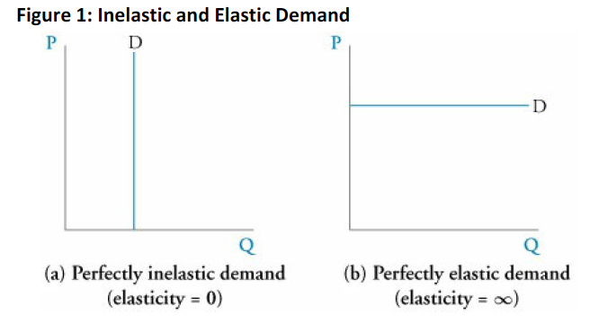

Few or no substitutes drives the demand of a good to be inelastic. If the portion of income spent on a good is high, the demand will likely be elastic. Elasticity tends to be greater the longer the time period since the price change, making the effect greater.

Elasticity is not the slope as it should be measure as percentage changes. Besides, it is calculated considering the % change on quantity in the numerator. That is why, a curve with slope zero is considered as a perfectly elastic curve, where the elasticity tends to infinity.

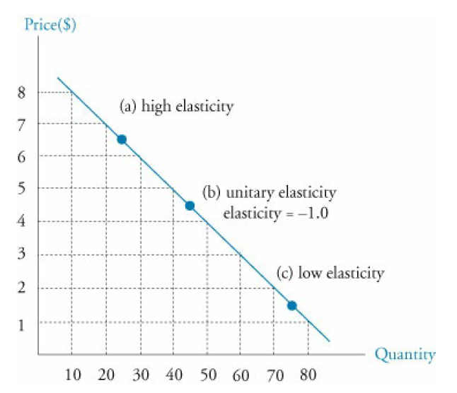

High elasticity: >1, at the beginning of the curve, elastic range.

Low elasticity: <1, at the end, inelastic range. If it is calculated, it will be also inelastic.

Unitary elasticity: =1, at the middle, the point of greatest total revenue (PxQ).

**Income elasticity of demand**

Sensitivity of the quantity demanded when the income changes. It is calculated as % change in quantity / % change in income.

For normal goods, the ratio is positive (an increase in income increases quantity).

For inferior goods, the case is the opposite.

**Cross price elasticity of demand**

Refers to the sensitivity that arise from the changes in price of a related good and it is calculated as % change in quantity of the studied good / % change in price of the related good.

Substitute good: Increases of price of the related good leads to an increase of quantity of the studied good. Elasticity is positive.

Complement good: Increases of price of the related good leads to a decrease of quantity of the studied good. Elasticity is negative.

**Calculating Elasticities**

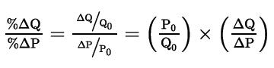

The last bit of the formula is important as there are times where the slope of the function will be given (as in the example of the book).

When a function with more than just the price is given, and an elasticity wants to be calculated, simply substitute all the variables but the one of interest. Calculate the quantity and then, with the slope, quantity and price calculate the elasticity.

Interpretations can be done as 1% change in price will lead to a x% (elasticity) change in quantity.

## Compare substitution and income effects

Substitution happens when increases (decreases) of prices lead to decreases (increases) of quantity of the same good. The income effect comes due to the changes of prices and refers to the move of more or less consumption towards a good. So, the substitution effect has always one outcome while the income effect depends of other variables.

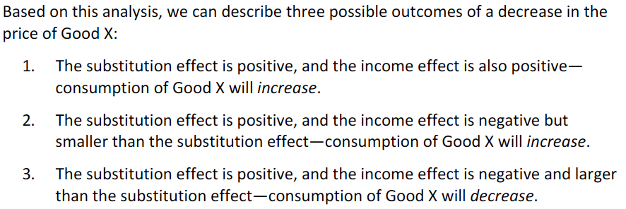

Study the graphs in depth, I don’t really get why does the substitution effect generates a parallel move of the budget line: it does not move it pararell, the income effect moves it pararell.

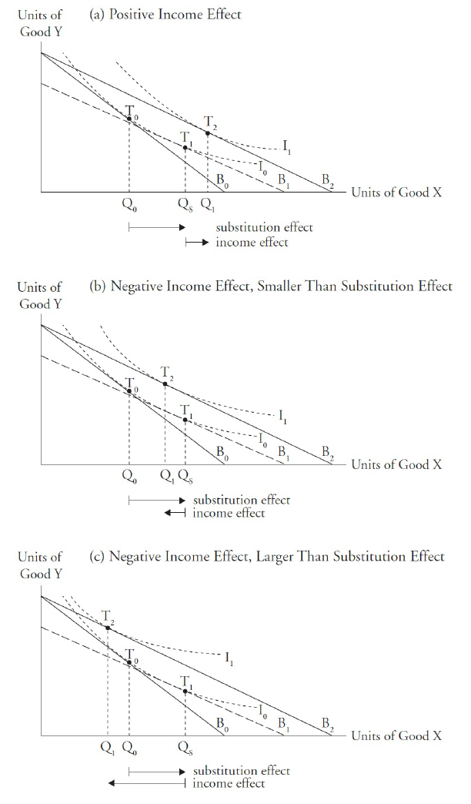

## Distinguish between normal goods and inferior goods

Normal good -> Positive income effect

Inferior good -> negative income effect

A good can be normal and inferior only for certain ranges of income.

Giffen good: is an inferior good for which a negative income effect outweighs the positive substitution effect when the price falls. This good will have an upward-sloping demand curve.

Veblen good: a higher price makes the good more desirable. Positively sloped demand for certain ranges of price.

## Describe the phenomenon of diminishing marginal returns

Factors of production:

* Land
* Labor
* Capital
* Materials

The production function is the quantity of output that a firm can produce in function of capital and labor employed.

Marginal product (slope): Begins increasing due to the benefits of labor or specialization of task (the next worker’s productivity is higher). At a point in time, the marginal product begins to decline known as diminishing marginal productivity, where the labor has diminishing marginal returns. There is even a point where the addition of one more worker implies a negative marginal product, in theory.

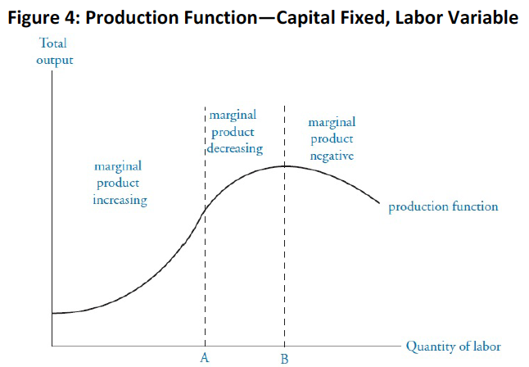

## Determine and interpret breakeven and shutdown points of production

Short run -> some factors of production are fixed, normally capital.

Long run -> all factors are variable. Then all cost are variable.

**Shutdown and breakeven under perfect competition**

In the short run, the firm needs to cover only its variable cost to continue operating to minimize losses. In the long run, the firm should shut down if the price is less than the average total cost.

For perfect competition, price = marginal revenue = average revenue and the firms are price-takers. In the long run equilibrium, companies make zero economic profit.

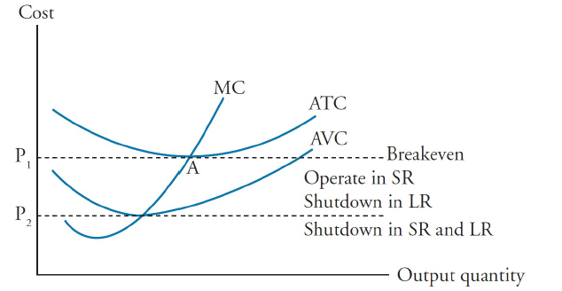

Here, at point A economic profits are zero. Between P1 and P2, the company must operate as it can still cover some of the fixed costs and minimize its losses.

The reason why in the long run it should shutdown, is because all costs are variable.

Short run shutdown point -> average revenue < average variable cost.

Long run shut down point -> average revenue < average total cost.

Break even point -> average revenue = average total cost.

Price-searcher firms – those that face a downward-sloping demand curve. For these ones, the same analysis can be done just by considering that price is no longer equal to marginal revenue. Conditions:

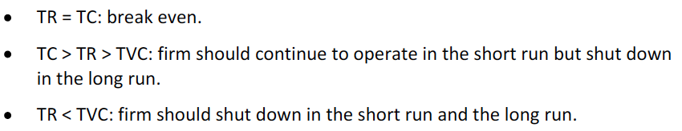

## Describe how economies of scale and diseconomies of scale affect costs

The long run average total cost graphs all of the minimum ATC for each given plant size in the different short runs.

Minimum efficient scale – scale at which the production cost is minimized.

Economies of scale = increasing returns to scale. It results from labor specialization, mass production and efficiencies (Also lower raw material prices might be negotiated).

Diseconomies of scale result from increasing bureaucracy of larger firms leading to inefficiency, management trouble, labor motivation and greater innovation barriers.

Over a range of scales, the LRATC might be constant or flat, this is known as constant returns to scale.

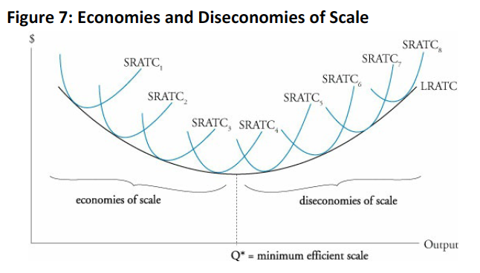

# Reading 15: The firm and market structures

## Describe characteristic of perfect competition, monopolistic competition, oligopoly and pure monopoly.

Differentiation factors between types of markets:

* Number of firms and their sizes.
* Elasticity of the demand curves.
* Ways of competing.
* Entering/exiting barriers.

Perfect competition: identical products, many firms, low barriers, compete on the basis of price. Perfectly elastic demand curves are faced due to the low market power.

Monopolistic competition: products are not identical do to combinations of quality, features and marketing. The demand is elastic, prices are similar but not identical and barriers are low. Due to differentiation, changes in prices will not necessary mean for a consumer to change of product.

Oligopoly: few firms competing, each firm considers the actions and reactions of others to set price and strategies and products can be quite similar or differentiated. High entry barriers due to economies of scales and marketing leadership. The demand can be more or less elastic than in monopolistic competition.

Monopoly: single seller, no close substitutes. The firm can then choose prices, there are high barriers. A natural monopoly is a situation where having one firm is better for the economy than having two.

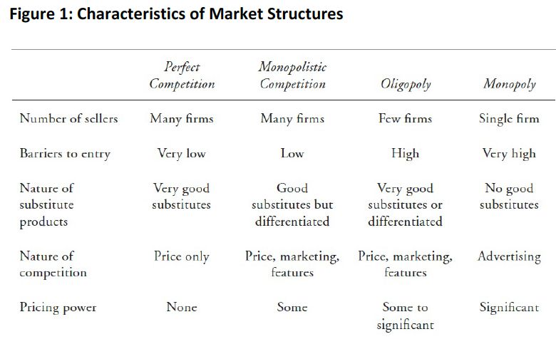

## Explain relationships between price, marginal revenue, marginal cost, economic profit and the elasticity of demand under each market structure

## d. Describe and determine the optimal price and output for firms under each market structure.

## e. Explain factors affecting long run equilibrium under each market structure

**Perfect competition**

Individual firm’s demand:

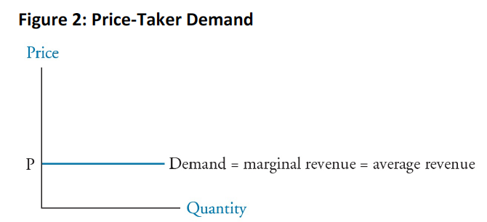

The rule to maximize benefits is marginal cost = marginal revenue:

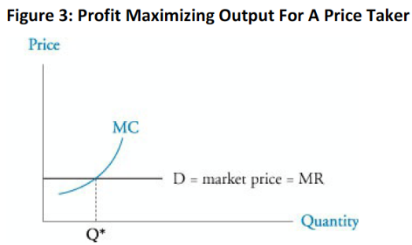

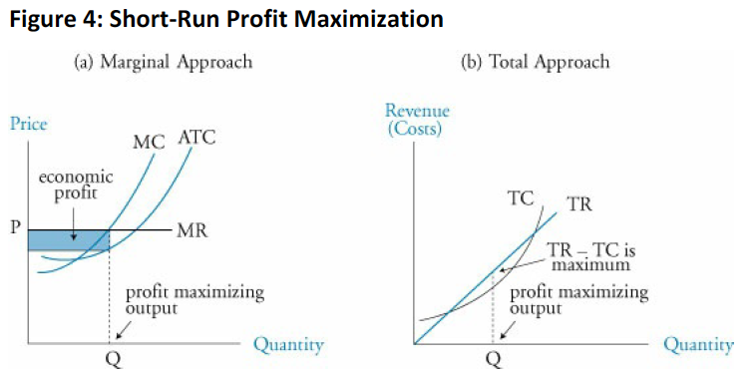

No company earns economic profits and the ATC for each company is the minimum (equilibrium):

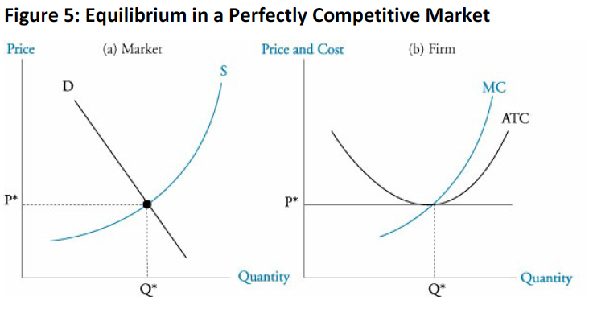

The shutdown point is when the price equals the average variable cost.

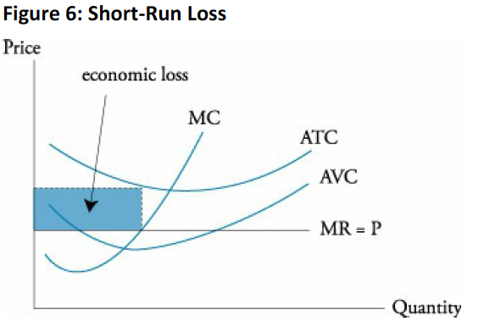

*Normal profit = 0 economic profit

The **short run supply curve** for a firm is the marginal cost line above the average variable cost curve, as it the line through which the company will expand its supply. The market supply will then be the sum of all of the firms’ MC lines:

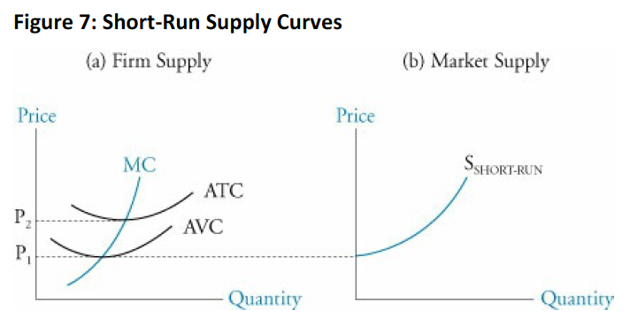

When there is a change in demand, like an increase, in the short run the firms will likely have economic profit. However, in the long run, the scale of production of certain firms will increase and new firms will enter, leveling the profits back to zero (as the price will decrease due to an increase in the market’s supply).

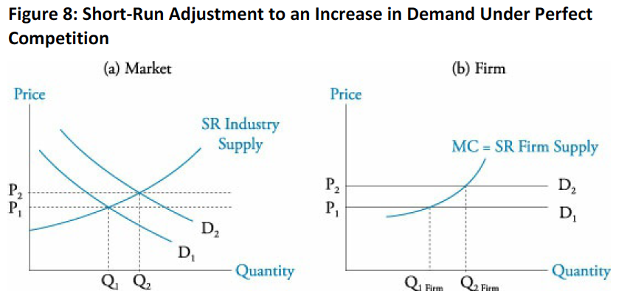

Downsizing -> reducing size to reduce economic loses.

It is important to note that when new firms enter due to a supply shortage, the supply curve of individuals decreases while the one of the industry increases. This will generate a decrease in price and in profits until equilibrium. The same happens in the opposite situation.

The following situation expresses the dynamism of the market with permanent changes in demand: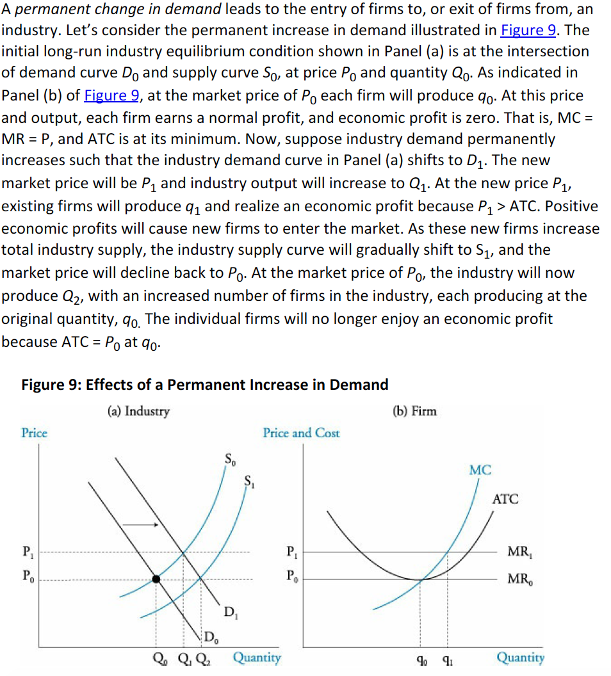

**Monopolistic competition**

Characteristics:

* Large number of sellers with no market power.
* The average market price is one guidance tool for participants.
* Collusion (price fixing) is not possible due to the number of participants.
* Differentiated products.
* Price, quality and marketing are the variables through which firms compete.
* Low barriers to entry.
* Highly elastic demands.

When MC = MR, profits are maximized. In the short run, the firms can face economic profit. However, in the long run, the profit comes to zero:

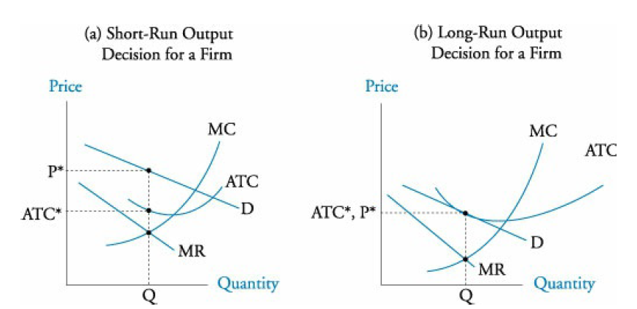

Comparison between a long run equilibrium under monopolistic and perfect competition:

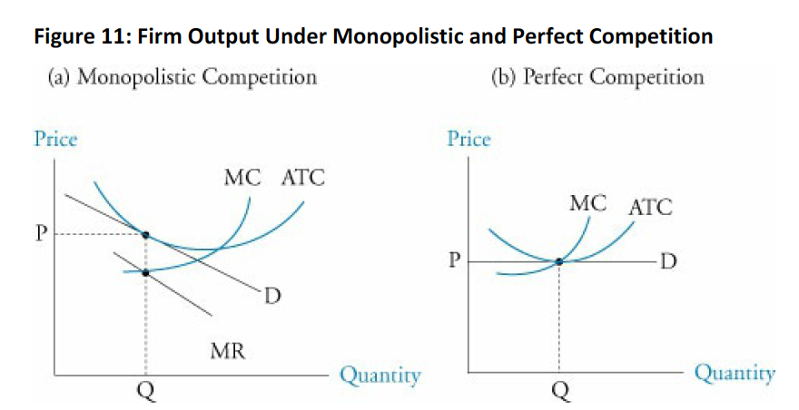

Main differences: higher price, not minimum ATC.

In monopolistic competition, firms look for product innovation (making products more desirable), advertising (higher than the ones affronted under perfect competition and monopolies) and brand names.

**Oligopoly**

* High barriers of entry.
* Few firms.
* Firms are interdependent -> a price change from one firm might mean a price change from another firm.

Due to these characteristics, there are four models to explain oligopolies:

1. Kinked demand curve model

It states that an increase in a firm’s product will lead to a decrease it its competitors’ prices. The more elastic bit of the demand shows that whenever a firm increases their price, the quantity will be decreased with a high sensitivity due to the fact that competitors will not increase their prices. If a firm decreases its price, others will match it, meaning that their change in demanded quantity will be small. Qk is the profit-maximizing level of output:

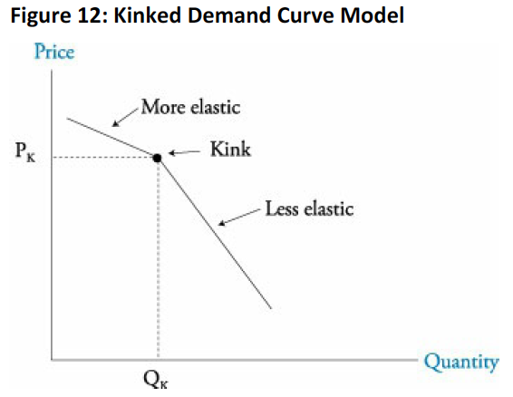

Due to the kinked demand, there is a gap in the marginal revenue. If the marginal cost passes through the gap, the profit maximizing price will be located at the kink. The thing with this model is that it does not explains where the kin should be located:

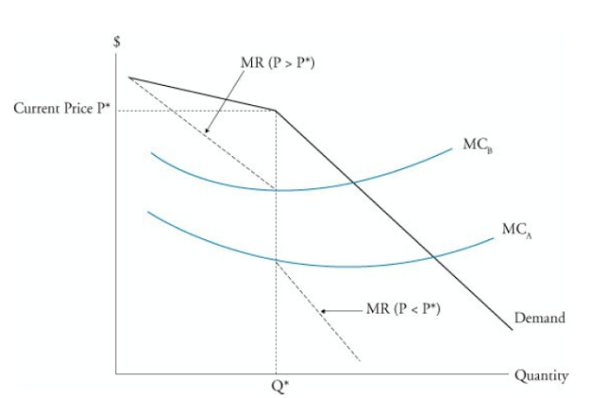

Why does the MR jumps (mathematically)?

1. Cournot duopoly model

The model considers that both firms have identical constant marginal costs and that each firm knows the quantity. This way, the firm substracts the quantity from the market demand curve to construct its own function (assuming that the other company will continue its behavior). However, firms will do this simultaneously until they reach equilibrium, meaning that they will reach a price lower than under a monopoly but higher than their marginal cost (the price of perfect competition). If more firms enter, the price will be pushed down.

1. Nash equilibrium model (prisoner’s dilemma)

The equilibrium is reached when there is no other choice that takes a firm to a better position than where it is. Prisoner’s dilemma outcomes:

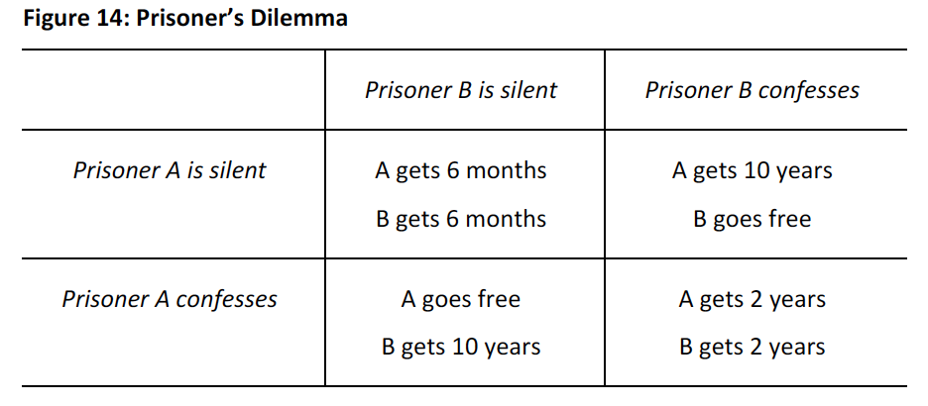

Here, the Nash equilibrium will be for both to get two years (no six months, since each prisoner has a way to go free if he confesses and the other does not. This means, that the prisoners could improve their situation). No matter what the other one does, the best outcome comes from confessing. Another example:

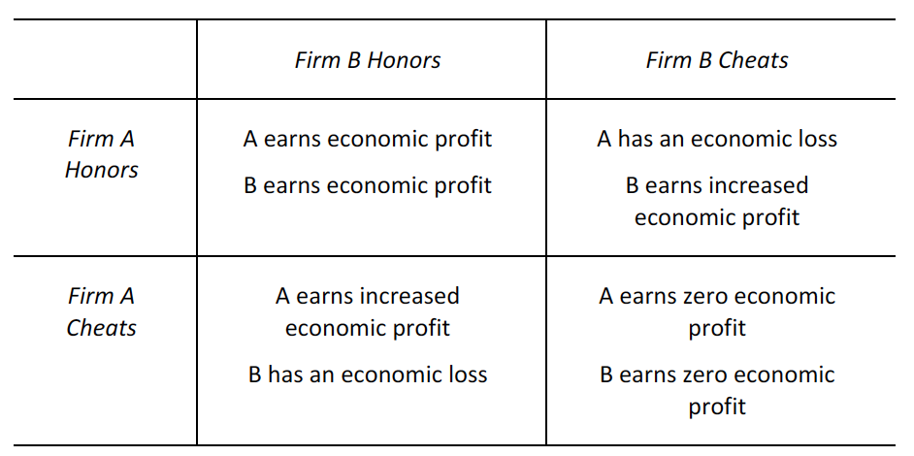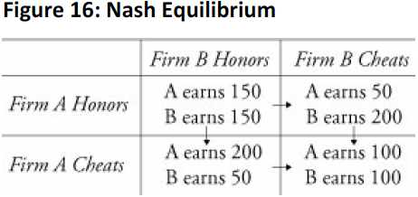

By both cheating, the Nash equilibrium is set, since there is no way from this point that a firm could unilaterally change its position to improve. If both honor the commitment, any firm could improve their situation by cheating. For collusion to be successful, there should be:

* + Less firms.
  + More similar products.
  + Similar cost structures.
  + Is not convenient for companies to be out of the cartel

1. Stackelberg dominant firm model (dominant firm model)

Here, there is a dominant firm and there are competitive firms. Since the dominant firm believes that at lower prices, the quantity supplied by competitive firms will decrease, its demand curve tends to get closer to the market’s demand. If a competitive firm decreases its price, the overall result will be an exit of competitive firms and a gain in market share for the dominant firm (since it will also reduce its price).

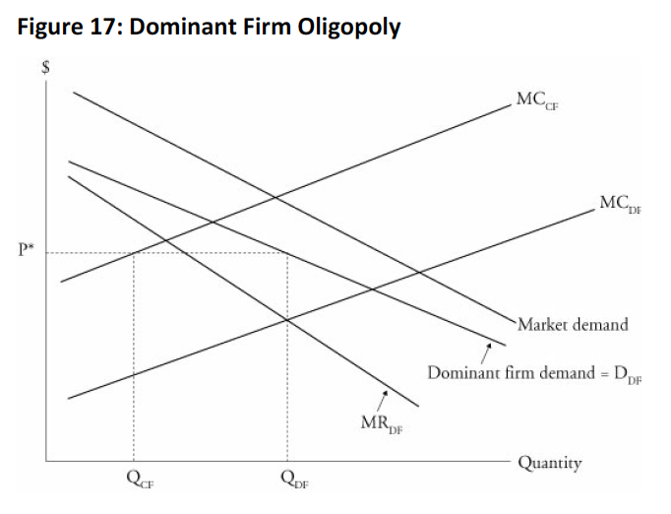

In general, the price of an oligopoly will be between a perfect collusion and perfect competition:

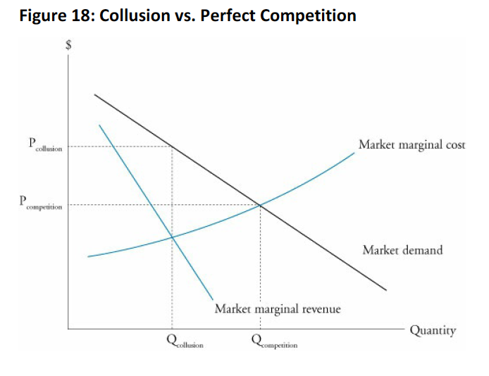

**Monopoly**

In monopoly, firms can either follow a single-pricing strategy or price discrimination.

In the long-run, monopolies gain positive economic profits.

The optimal output is when MC=MR and the demand curve will stablish the correct price. The optimal quantity will go with a price that lies in the elastic range of the demand curve.

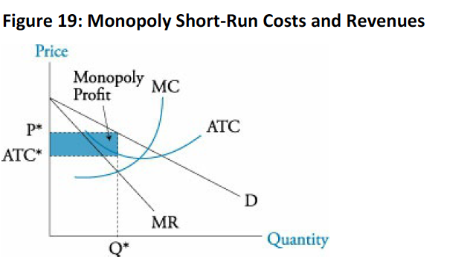

For price discrimination, the seller must face a downward-slopping demand, have at least two costumer groups with different price elasticities for the product and be able to prevent reselling of the product.

By discriminating, it is possible to earn more profit and reach larger output. Here, for simplicity, MC = ATC.

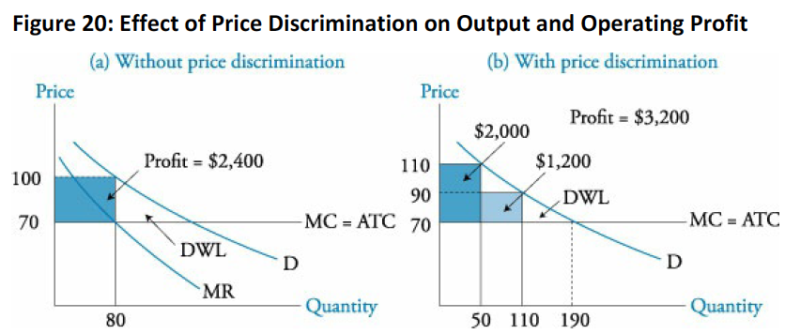

Here, it can also be seen the deadweight loss, which is the loss that the economy faces due to this inefficient way of competing. Here, the consumer and producer surplus are not maximized due to the lower outputs and higher price. With price discrimination, the DWL is reduced but, in this case, the producer is the one who is increasing its surplus while the consumer is reducing it (as they are paying the maximum price). Here, it can be seen how inefficiency is generated by comparing a monopoly with perfect competition:

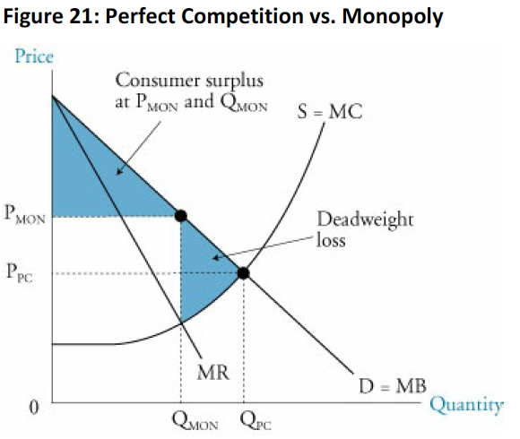

*Rent seeking: spend time and resources to try to establish a monopoly (causes inefficiencies)

**Natural Monopoly**

Are due to large economies of scale situations, where the marginal cost is lower. Here, the entry of new firms will rise the costs. The optimal output is found when MC=MR and shows that if two firms were producing the same quantity (half and half) the cost will be higher for both):

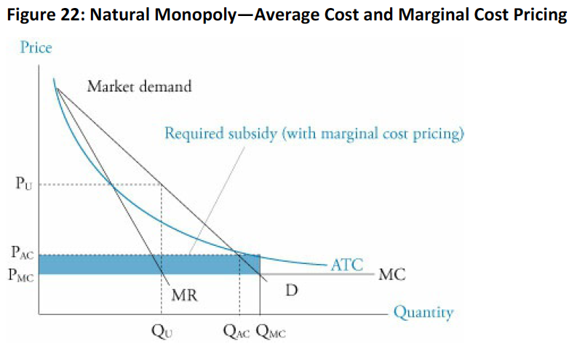

Regulators often use average cost and marginal cost pricing in order to ensure that the monopolies charge a determine price and produce a determined quantity.

Average cost pricing will result in PAC and QAC which force the firm to reduce the price where the ATC=D, increasing the output and reducing the price, increase social welfare and ensuring normal profit.

Marginal cost pricing, known as efficient regulation, forces the firm to produce and price where MC=D. This solution requires government subsidy to ensure normal profit.

Bidding of monopolies is also an efficient solution as the higher bidder will, in theory, bid an amount equal to the expected economic profits (which in the long run equal zero).

## Describe a firm’s supply function under each market structure

For markets different to a perfect competition, there is no well-defined supply function because the demand is negative and the production cannot be determined in function of price because P<>MR.

## Describe pricing strategy under each market structure

Perfect competition: MC = MR. Consider that P=MR=D.

Monopoly: MR = MC. Consider that P>MR and P>MC.

Monopolistic competition: MR = MC. Consider that P>MR and P>MC.

Oligopoly: Key characteristic is interdependence, then the pricing strategy depends on the assumptions.

* Kinked demand: a price decrease will be matched but not a decrease. MR = MC but the MR is discontinuous so for many cost structures it could work.
* Collusion: MC = MR. Like a monopoly but share through agreements.
* Dominant firm: One dominant, others follow. DF: MC = MR and price with its demand curve. Others will simply produce assuming that price and look where that price equals their MC.
* Game theory: The price will be between the monopoly and perfect competition price, depending on how the game goes. It is important to remember that firms will do what allows them to improve the most.

## Describe the use and limitations of concentration measures in identifying market structure

Concentration measure are often used as indicators of market power (due to the difficulty involved in measuring elasticities).

N-firm concentration ratio: sum of the market share of the largest N firms in a market. The limitation is that it might be relatively insensitive to mergers of two firms with large market shares.

Hernfindahl-Hirschman Index (HHI): sum of the squares of the market shares of n firms..

Another limitation for both cases is that barriers to entry are not considered.

## Identify the type of market structure within a firm operates

To do this, it is important to focus in the following characteristics:

1. Pricing power
2. Number of firms
3. Barriers to entry
4. Nature of substitute products
5. Nature of industry competition.

# Reading 16: Aggregate output, prices and economic growth

## Calculate and explain GDP using expenditure and income approaches

GDP- total market value of goods and services newly produced in a country. Resales are excluded as well as transfer payments made by the government.

Market values of the goods are the ones used for calculating GDP. Services and goods provided by the government are included at their cost. Not sold labor is not included.

Expenditure approach: sum of all the spending on newly produced goods and services.

Income approach: sum of all the amounts earned by the households and companies (includes wage, interest income and business profits).

In theory, through the two methods should produce the same result.

## Compare the sum-of-value-added and value-of-final-output methods of calculating GDP

The final output method simply sums the values of all the final goods and services produced.

The value-added method consists on summing the addition to value created at each stage of production and distribution.

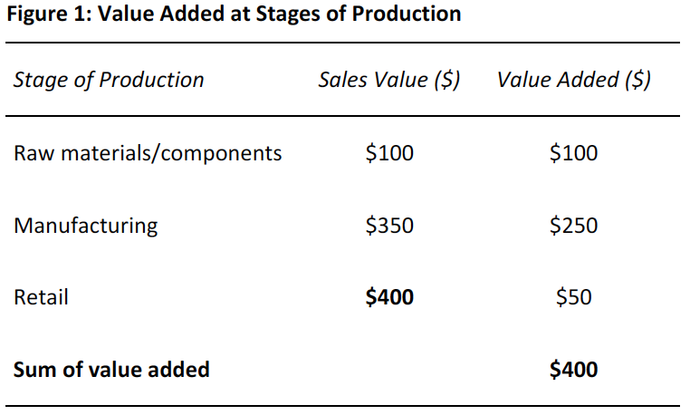

## Compare nominal and real GDP and calculate and interpret the GDP deflator

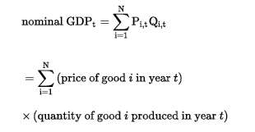

Nominal GDP is based on current prices.

Real GDP used a price base of a specific year, removing the effects of inflation.

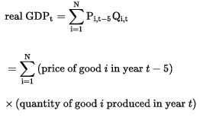

GDP deflator takes out the effect of price changes from the nominal GDP (converting it into a real GDP).

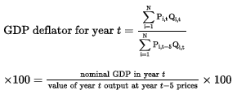

Per capita GDP simply divides the GDP by the population of an economy.

## Compare GDP, national income, personal income and personal disposable income

Under the expenditure approach, the GDP is calculated as follows:

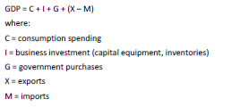

Under the income approach, the GDP is calculated as:



Capital consumption allowance refers to the depreciation of physical production capital.

The statistical discrepancy is simply an adjustment for the difference between the GDP through the income and the expenditure approach due to the different type and source of data that is used.

National income is the sum of the income received by all factors of production:

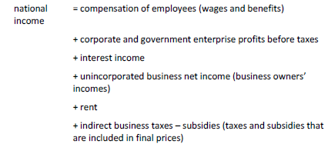

What is rent here??

Personal income is the pretax income received by households and is a determinant of consumption.

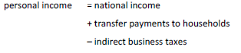



Personal disposable income is personal income after taxes. Is what households have available to safe or spend:



## Explain the fundamental relationship among saving, investment, the fiscal balance and the trade balance

The equality between the income and the expenditure approach can be stated as follows:



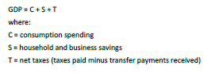

The right part of the formula is the income approach.

Solving S:



G-T is the fiscal balance, governments spending and receipts (positive will be deficit and negative surplus). X-M will then equal the balance trade (positive will be surplus and negative deficit).

When solving the equation for the fiscal balance, it can be seen that it must be financed a by trade deficit and an excess private saving over investments:



The trade deficit is associated with an inflow of foreign investment. Then, the deficit is financed by domestic and foreign capital.

## Explain the IS and LM curves and how they combine to generate the aggregate demand curve

Determinants of GDP:

* Consumption: Is in function of disposable income. The marginal propensity to consume and to save are calculated based on the disposable income.
* Investment: Is in function of expected profitability and cost of financing (economic output and interest real rates).
* Government purchases: Although it is seen as independent, it does consider the economic output and other variables.
* Net exports: Are in function of domestic and foreign disposable incomes and relative domestic and foreign prices.

IS curve (Income-Savings): Shows the investment of an economy considering income and interest rates, it actually shows an equilibrium between income and expenditure.

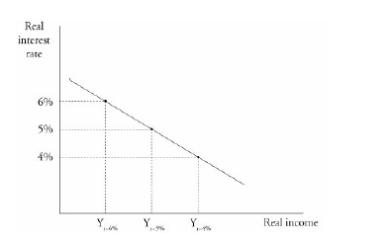

Decrease in interest rates increases consumption and investment. In order to keep on with the equilibrium (the formula that relates net savings, fiscal and trade balance) the income must increase so saving, tax receipts and imports can increase ((S-I) = (G-T) + (X-M) ).

LM curve (Liquidity-money): expresses the equilibriums in the money market. It relates income and interest rates showing these equilibriums. In order to keep an equilibrium in the money market considering a constant money supply, the income of the economy must increase whenever the interest rates increase to keep up with the demand of money.

Higher rates = lower money which individuals want to hold.

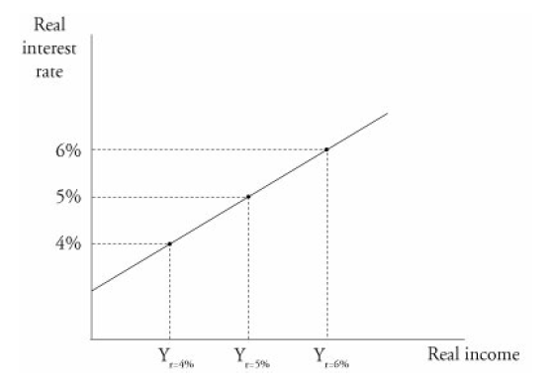

REVISAR COMO SE CONSTRUYEN IS Y LM

The overall equilibrium considers an equilibrium of both the money and the goods market:

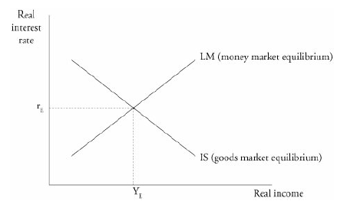

Movements in money supply shift the LM curve while changes in the demand build it.

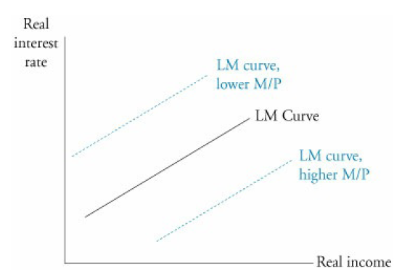

The aggregate demand curve:

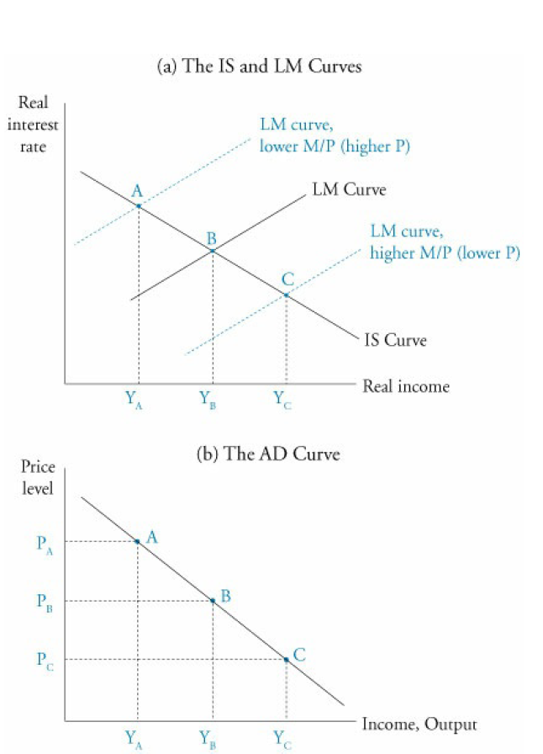

## Explain the aggregate supply curve in the short run and long run

It represents the amount of output that firms will offer.

Supply curves:

Very short run aggregate supply (VSRAS): from changes in demand, companies will adjust their labor and plant use instead of changing their prices; it is perfectly elastic.

Short run aggregate supply (SRAS): here, prices do change as demand varies as a result of changes in output prices but some input prices that remain sticky, suggesting an upward curve.

Long run aggregate supply (LRAS): All input costs vary in the long run proportionally to the price level, so the price has no effect on the aggregate supply. This output level is referred as potential GDP or full employment GDP.

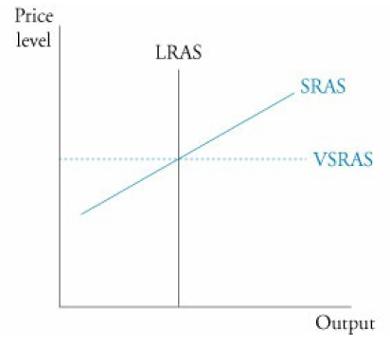

## Explain causes of movements along and shifts in aggregate demand and supply curves

**Shifts in the aggregate demand curve**

To remember the aggregate demand shofters, the formula GDP = C + I + G + XM is useful. A change in any of the mentioned factors triggered by the following could shift the demand:

* Increase in consumers’ wealth (C increases).
* Business expectations (I changes).
* Consumer expectation of future income (C changes).
* High capacity utilization (I increases).
* Expansionary monetary policy (happens when the economy is operating at its potential GDP. However, price increases might decrease the SRAS triggered by the monetary policy and return the output to the potential GDP).
* Expansionary fiscal policy (higher G and C and I)
* Exchange rates (net exports increase if thee exchange rates increases).
* Global economic growth (might increase net exports).

**Shifts in the short run affrefate supply curve**

* Labor productivity (holding wages constant).
* Input prices (decrease increase the output).
* Expectations of future output prices (higher expected prices will increase the supply).
* Taxes and government subsidies.
* Exchange rates (depending on the nature of the business it will affect the supply).

**Shifts in long run aggregate supply curve**

The LRAS is perfectly inelastic at the potential level of GDP.

* Increase in the supply and quality of labor (full employment level will increase).
* Increase in the supply of natural resources.
* Increase in the stock of physical capital.
* Technology (efficiency).

**Movement along the aggregate demand and supply curves**

Reflect the impact in changes of price levels.

## Describe how fluctuations in aggregate demand and aggregate supply cause short run changes in the economy and the business cycle

## Distinguish between the following types of macroeconomic equilibria: long run full employment, short run recessionary gap, short run inflationary gap and short run stagflation.

## Explain how a short run macroeconomic equilibrium may occur at a level above or below full employment

Recession -> declining GDP and rising unemployment, due to a reduction of the aggregate demand and SRAS. This will level back up through expansionary policies or due to the reduction of wages (due to the unemployment), leading to lower input prices and then, a higher output.

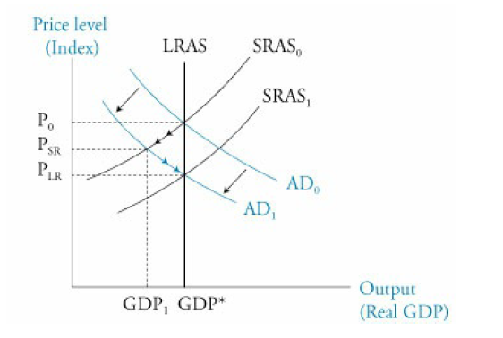

Inflationary gap -> is the difference between the potential output and the output (GDP) greater than the potential. This causes a rise in price levels. Either through higher competition among workers, raw materials and energy or by a government contractionary intervention, the economy goes back to the potential GDP.

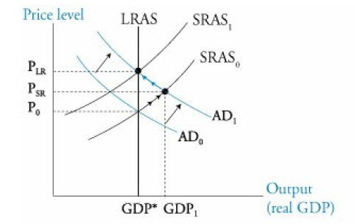

Stagflation -> Whenever the input prices increases, the SRAS decreases, implying higher level prices as well as a lower output. Due to a subsequent decrease in input prices or to an increase in the aggregate demand (for any reason) could manage the economy to get back to its potential output (in this last case, however, at higher price levels… this is why stagflation is a difficult situation). Another option could be to reduce prices of productive inputs to increase the SRAS, however it is a slow and non-popular method.

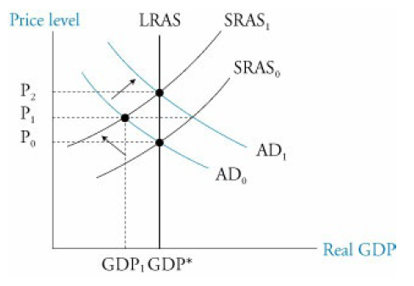

Increase in the SRAS due to a decrease in input prices -> The GDP goes further than the full employment GDP.

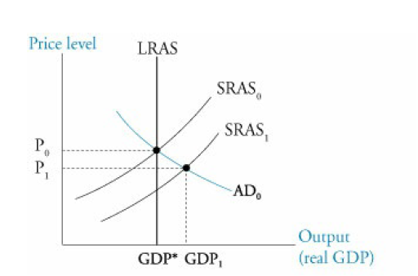

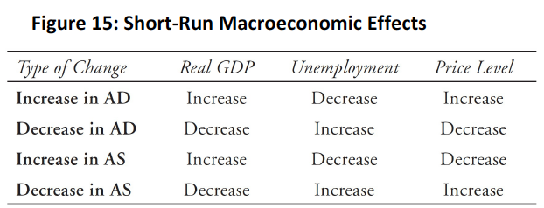

## Analyze the effect of combined changes in aggregate supply and demand on the economy

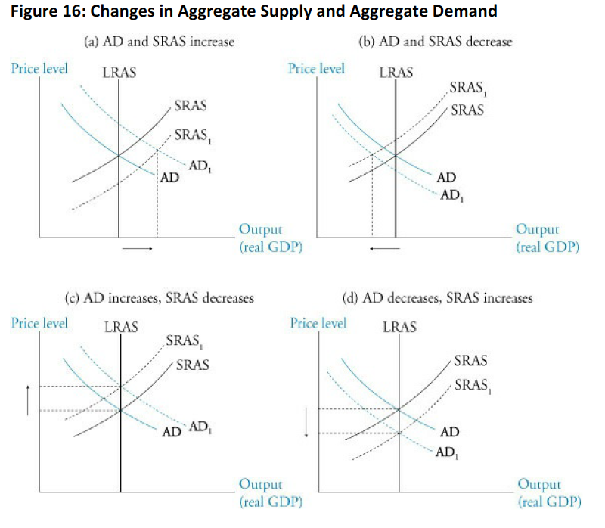

## Describe sources, measurement and sustainability of economic growth

Sources:

* Labor supply: people over sixteen available to work but unemployed. It is affected by changes in population and the participation rate.
* Human capital: refers to the extent to which the workforce is educated and skilled.
* Physical capital stock: machines and others.
* Technology.
* Natural resources.

Economy sustainable growth: it can be measure by adding the potential growth in labor force plus the growth in productivity. This rate shows the growth of the potential GDP and is determinant in long term equity returns.

## Describe the production function approach to analyzing the sources of economic growth

The production function describes the relationship of output to labor, capital and productivity.

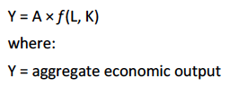

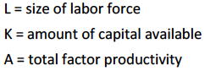

A is related to technological advances and it represents the growth in output which cannot be explain by increases of labor and capital.

The function exhibits diminishing marginal productivity. This is why just by investing in capital is not enough.

## Distinguish between input growth and growth of total factor productivity as components of economic growth

Solow or neoclasical model:



WL and Wc are the percentage share that compose the national income.

# Reading 17: Understanding Business Cycles

## Describe the business cycle and its phases

Unemployment and real GDP are essential to determine where in the cycle is the economy.

Phases:

* Expansion: GDP increasing, increasing employment, consumerism, investment.
* Peak: GDP stops increasing and starts decreasing, before reaching to the peak, inflation is high.
* Contraction or recession: GDP decreasing, inflation decreasing, declines in most sectors.
* Trough: GDP stops decreasing and starts increasing, recovery begins. After a trough, unemployment would not start decreasing until the expansion is convincing.

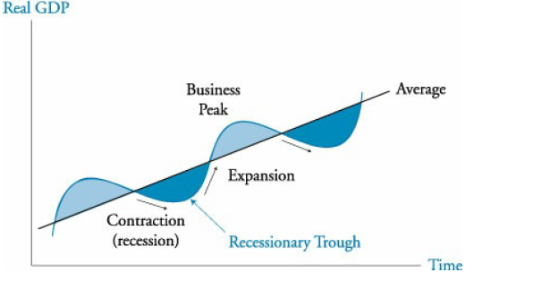

Regularly, two consecutive quarters that follow a tendency mark the beginning of an expansionary or a recessionary phase.

Business cycle apply to economies which are based on businesses and not on agriculture or other type of activities.

## Describe how resource use, housing sector activity, and external trade sector activity vary as an economy move through the business cycle

**Resource use fluctuation:** The inventory levels give an idea of the business cycle. The inventory-sales ratio tends to be high whenever inventories begin to accumulate during an expansion, suggesting closeness to a peak. The same happens the other way around. This is because companies tend to vary output to confront economic changes, then labor and capital are not constantly varied.

**Housing sector activity:** Cyclical swing in the housing market can bring effects to the economy. The market is mainly affected by:

* Mortgage rates.
* Housing costs relative to income.
* Speculative activity (due to expectations).
* Demographic factors (25- to 40-year-old segment).

**External trade sector activity:** Trade level depends on the domestic GDP growth, trading partners growth and currency exchange rates. High domestic GDP -> high imports; High foreign GDP -> high exports; High exchange rate (lower value of the domestic currency) -> high exports (low imports).

Typical business cycles can be summarized as follows:

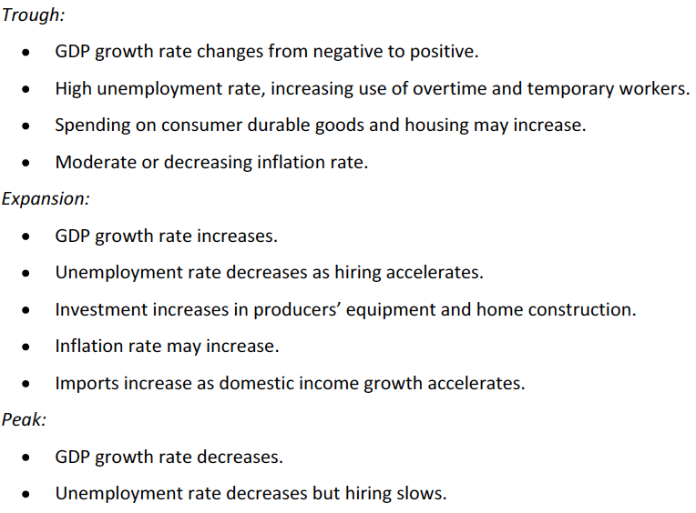

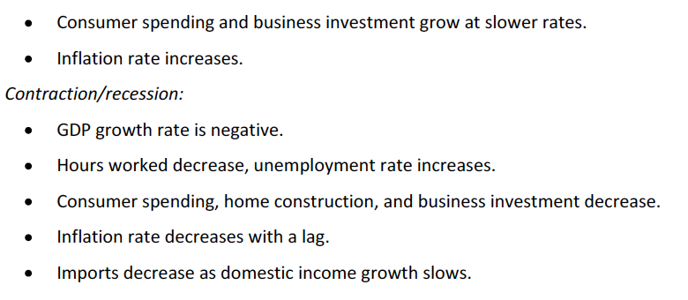

## Describe theories of the business cycle

**Neoclassical school:** They conclude that business cycles result from deviations of a long-term equilibrium where full employment is met. They believe that changes in aggregate demand and supply are mainly driven by technology. In some crisis, this has not been fulfilled since the economy has been significantly below its full employment for long periods.

**Keynesian school:** They believe that the changes in demand are mainly driven by expectations. Their proposal points to changes in the demand through monetary and fiscal policies. They also believe that wages are downward sticky, making them non-helpful to increase the supply.

**New Keynesian school:** They add the downward sticky theory to the other productive inputs (they stay constant even if the general prices increase).

**Monetarist school:** They believe that a predictable money supply policy will help the economy to grow and assure that recessions are the result of bad decisions in this specific field.

**Austrian school:** They believe that business cycles are caused by government intervention, which generate expectation and when the reality comes, the swings are generated.

**New classical school:** They introduced the real business cycle theory. They believe that real economic variables like changes in technology and external shocks moves the economy. They argue that policy makers should not force out the economy from expansions and contractions since they are efficient market responses to real shocks.

## Describe types of unemployment and compare measures of unemployment

Categories:

* Frictional unemployment: is a necessary lag for employers to find skilled employees.
* Structural unemployment: Differs to frictional as it is believed that workers lack of the skills required by employers and is normally caused by creation of new jobs (while eliminating others) due to technological changes.
* Cyclical unemployment: causes by the changed of the economic activity. It is positive when the economy is not operating at its full capacity.

Unemployed: someone who is not working and is looking for job. If this goes on for several months, it is considered as a long-term unemployed.

Unemployment rate: % of people unemployed in the labor force (does not include voluntarily unemployed people).

Underemployed: someone employed at lower wage than disserved or who works part time and will like to work full time.

Participation ratio (activity or labor force participation rate): % of working age population who are employed or looking for a job. Expands when the economy expands, causing the unemployment to rise although the number of employed workers is increasing.

Discouraged workers: available to work but are not employed nor looking for a job.

Productivity: Decreases early in contractions and increases early I expansions due to the lag of laying off or hiring new personnel.

## Explain inflation, hyperinflation, disinflation and deflation

Inflation: Persistent increase in price levels over time. It favors borrowers at the expense of lenders, as these last ones receive less money.

Hyperinflation: an inflation which is out of control.

Disinflation: refers to decreasing inflation rates over time but above zero.

Deflation: negative inflation rate. Causes recessions since consumer delay purchases expecting to see lower prices.

## Explain the construction of indexes used to measure inflation

CPI-> best known indicator of US inflation.

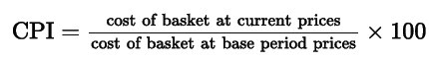

Index for personal consumptions expenditures -> surveys businesses rather than consumers.

GDP deflactor

Producer price index

Wholesale price index

Headline inflation: Price indexes for all goods.

Core inflation: Price indexes that exclude food an energy, as they are more volatile. This is then more useful to look at tends.

## Compare inflation measures, including their uses and limitations

Laspeyres index: Uses a constant basket of goods of a base period. They are biased because:

* New goods, which are more expensive, biases the index upward.
* Quality changes: if the price increases due to quality, is not inflation.
* Substitution: This because if the consumers substitute a good in the basket, then the index will not be precise.

Hedonic pricing: Adjusts the index for product quality.

Fisher index (chained or chain-weighted index): adjust for substitution, is the geometric mean of a Laspreyres index and a Paasche index.

Paasche index: uses current consumption period weight.

## Distinguish between cost-push and demand-pull inflation

**Cost-push inflation:** results from a decrease in the aggregate supply caused by increases in input prices. This decrease will reduce the output and increase the price. If the government installs an expansion policy, the demand will increase, recovering the previous output but at higher price level:

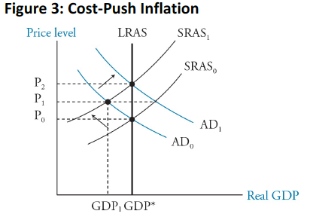

The most likely trigger of this effect is an increase in wages, which emerges when unemployment is low normally.

Non-accelerating inflation rate of unemployment (natural rate of unemployment)

If the wages increase in line with gains in productivity, there is no wage inflation (unit labor costs, ratio of compensation per hour to units per hour, is a good measure of productivity). The expected inflation normally draws a line in which the wages tend to move to.

**Demand-pull inflation:** Appears from an increase in the aggregate demand.

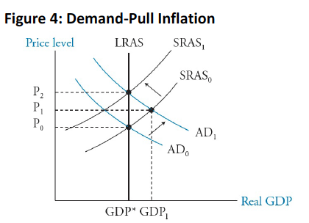

Here, the aggregate demand is increase by whatever reason and then, because unemployment is low, wages will increase, reduction the aggregate supply and driving the price levels to p2.

The main difference between the two inflation is that one begins with a decrease in the output and the other one with an increase.

## Interpret a set of economic indicators and describe their uses and limitations

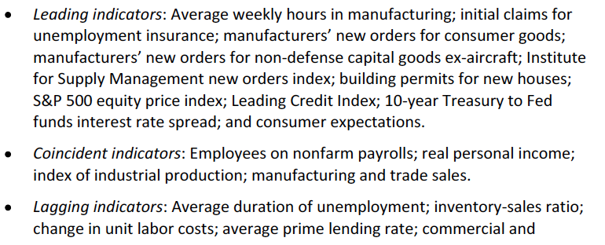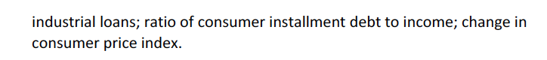

# Reading 19: Monetary and Fiscal Policy

## Compare monetary and fiscal policy

Fiscal: use of spending and taxation. Also used as a tool for redistribution of income and wealth.

Monetary: quantify money and credit. Expansion (more money and credit) = accommodative or easy and contractionary = restrictive or tight.

## Describe functions and definitions of money

Money functions:

* Medium of exchange.
* Unit of account.
* Store of value.

Narrow money: amount of currency in an economy plus balances in checkable bank deposits.

Broad money: narrow + any other liquid assets.

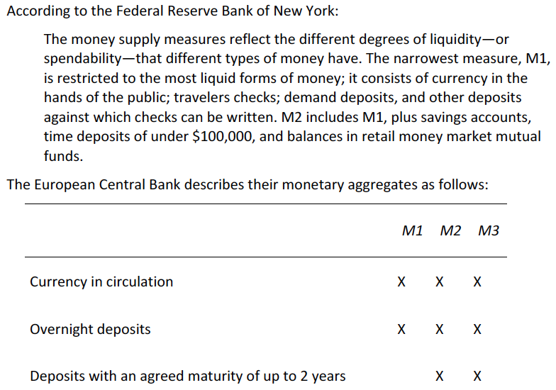 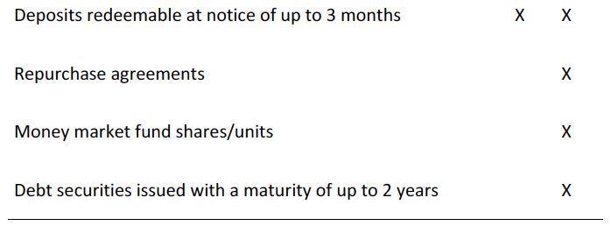

## Explain the money creation process

Promissory notes: banker promised to return gold on demand of the depositor. The then became a medium of exchange.

Fractional reserve banking: banks hold only a portion of the deposits and lends the rest in exchange of interest.

*Excess reserves: money not needed for reserves).

The process of cash multiplication is made by lending, spending and depositing. The amount of money that can be created is calculated as:

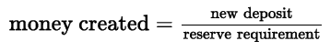

The money multiplier is by how many times is the money created from the original deposit:

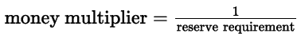

**Relationship of money and the price level:**

The quantity theory of money states that:



Velocity is the average number of times per year each unit of money is used to buy goods. Because velocity and the real output are so difficult to move, a change in money supply will then affect inflation. This means that real variables remain constant and are not affected by monetary variables (this is known as monetary neutrality).

## Describe theories of the demand for and supply of money

The demand for money is the amount of wealth hold in the form of money. The reasons for holding money are:

* Transaction demand.
* Precautionary demand: keep money for future needs. Normally increases with the size of the economy.
* Speculative demand: money to take advantage of future investments or because they expect negative returns from their current investments.

At higher interest levels, people demand less money since they prefer to invest it. The supply is inelastic as it purely depends on the central bank.

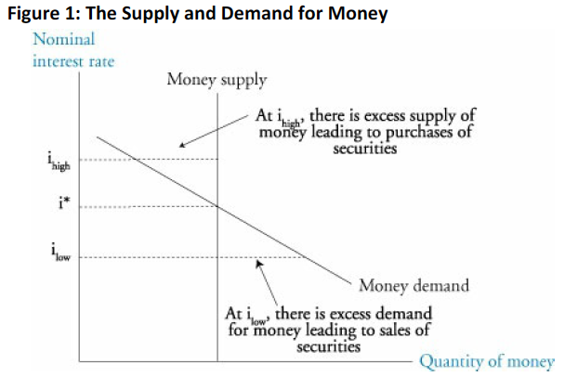

Central banks can also trigger changes by adjusting the supply:

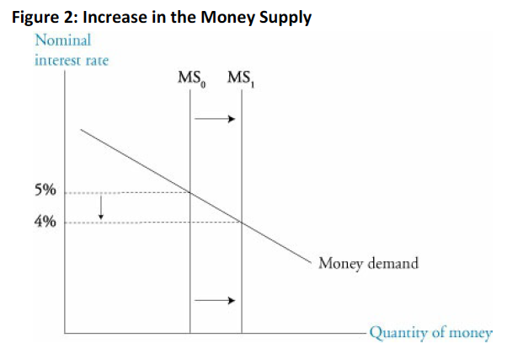

## Describe the fisher effect

Simply states that the nominal rate is computed as follows:

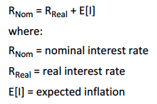

And it says that normally the changes happen in inflation, like in money neutrality.

## Describe roles and objectives of central banks

Key roles:

* Sole supplier of currency: they are the only ones who inject money. The money supplied by the bank is the legal tender. Because it is not backed by a tangible value, it is known as fiat money.
* Banker to the government and other banks,
* Regulator and supervisor of payments system.
* Lender of last resort.
* Holder of gold and foreign exchange reserves.
* Conductor of monetary policy.

The primary objective is to control inflation. High inflation leads to menu costs (business changing prices) and shoe leather costs (cost of constantly making deposits and withdrawals).

Other goals:

* Exchange rate stability.
* Full employment.
* Sustainable positive economic growth.
* Moderate long-term interest rates.

Targets of inflation are of 2-3% (not zero because of the risk deflation).

Pegging -> maintaining a desired exchange rate with a specific currency, committing the country to make its inflation rate equal to the one of the foreign currencies.

## Contrast the costs of expected and unexpected inflation

Perfectly anticipated inflation -> expected = real

High inflation costs: holding money is expensive.

Unanticipated inflation brings high costs. Higher than anticipated make borrowers win at the expenses of lender and the same happens the other way around. Then, lenders will issue their loans at higher rates to compensate this risk, slowing the economic activity. Also, if inflation is higher than expected, firm inventories might increase, which could lead to a reduction in the output from companies, laying off workers and reducing expenditures. This could extend business cycles.

## Describe tools used to implement monetary policy

Tools:

* Policy rate: Is the rate at which the bank lends to other banks (discount rate in the US, refinancing rate in Europe or the two-week repo rate (through repurchase agreements) for the case of England. Besides, the bank establishes a target rate at which banks should lend each other on overnight loans and uses open market operations to control it.
* Reserve requirements: increasing it decreases the funds available for lending and the money supply (which increase interest rates).
* Open market operations: buying and selling central banks’ securities, which change the money supply and, then, the interest rate.

## Describe the monetary transmission mechanism

Refers to the way in which monetary policy affects inflation. There are four ways through which the changes in policy rates get to the prices:

* Banks’ short-term lending rates increase due to the increase in the policy rate. Credit is affected, variating the aggregate demand and then, the price levels.
* Asset prices change in function of the changes in interest rates, which might incentive or disincentive consumption.
* Expectations are generated base on the policy decision, affecting the price levels.
* Changes in rate may attract foreign investors, appreciating then the domestic currency, reducing exports (which moves the aggregate demand).

## Describe qualities of effective central banks

Three essential qualities to be successful:

* Independence: Free from political interference (for instance, in election, this independence is quite important for the best interest of the economy). They are two types independence: Operational (the central bank can assign independently the rate) and target (the central bank defines how inflation is computed, sets a target and determines the horizon of the target) independence. Most banks have operational independence.
* Credibility: Following it through its stated intentions and complying with its targets.
* Transparency: Disclose the state of the economic environment (inflation reports). Being clear.

## Explain the relationships between monetary policy and economic growth, inflation, interest and exchange rates

Although in the long term, due to money neutrality, the effect of monetary policy on the real output is null, on the short run, it can affect. An expansionary policy may include:

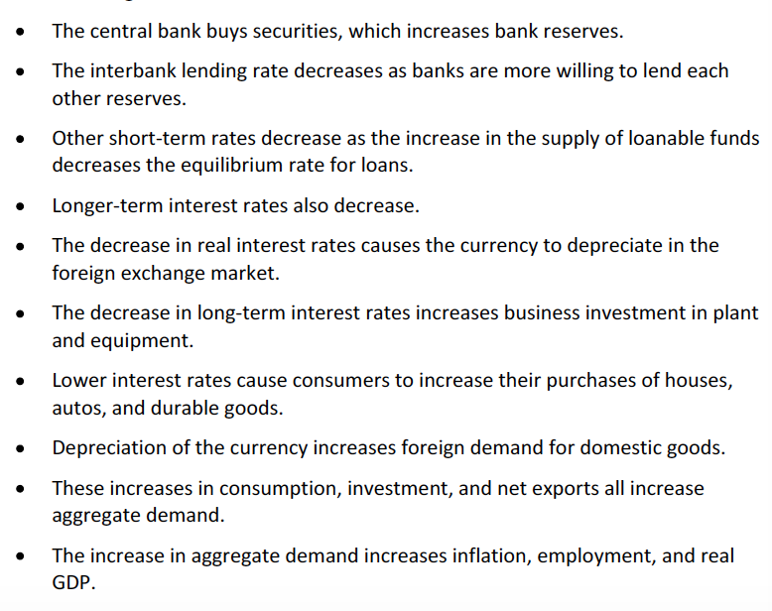

## Contrast the use of inflation, interest rate and exchange rate targeting by central banks

Interest rate targeting: adjusting the money supply to adjust interest rated.

Inflation targeting: the most common is 2% + - 1%. Usually, the inflation target has a 2-year horizon.

Exchange rate targeting: commonly used for developing countries. Here, the country buys and sells (which affects the money supply and interest rates and the exchange rate) foreign currency to control the exchange rate with and specific currency. Here, the target is to have the same inflation rate so that the exchange rate does not vary. The counter effect of this alternative is that money supply varies a lot.

## Determine whether a monetary policy is expansionary or contractionary

Real trend rate: long-term sustainable real growth rate.

Neutral interest rate: is the growth rate of money supply that maintains the money supply constant:



When the policy rate is above the neutral rate, the monetary policy is contractionary.

## Describe limitations of monetary policy

Bond market vigilantes: investors sell bonds since the expect high future inflation.

Liquid trap- an elastic money demand makes individuals willing to hold more money without any change in interest rates. An expansion of the money supply will not change the interest rates since people will not invest the money, they will hold to it. Happens when deflation appears.

If banks are not willing to learn, this will also fail to increase the monetary supply.

Quantitative easing- purchase of governmental bonds. This reduces the interest rate and injects liquidity.

In developing economies, the deal is much harder since there is low liquidity, low confidence and low technological development.

## Describe roles and objectives of fiscal policy

Keynesian economists: When the economy is operating at a lower point than the full employment, fiscal policy can be a great stimuli.

Monetarists: believe that the effect of fiscal policy is temporal and that the monetary policy should be used to fight inflation (although it does not says the same about the aggregate demand and the output).

Discretionary fiscal policy: taxing decisions that tend to stabilize the economy.

Objectives of fiscal policy:

* Influence the economic activity.
* Redistribute wealth and income.
* Allocate resources.

## Describe tools of fiscal policy, including their advantages and disadvantages

**Spending tools**

* Transfer payments: consists on taxing some and making payments to others. Example: social security. Is not included in the GDP computations.
* Current spending: purchases made by the government.
* Capital spending: Government spending in infrastructure.
* Justification: servise that benefit residents of countries, infrastructure to enhance economic growth, support plans to reach targets, provide a minimum standard of living…

**Revenue tools**

* Direct taxes.
* Indirect taxes

**Desirable attributes of tax policy:** simple, efficient, horizontal and vertical equality, sufficiency.

**Advantages of fiscal policy tools:** social policies to prevent consuming something.

**Disadvantages of fiscal policy tools:** Direct taxes and transfer payments implementation is slow, capital spending is slow too.

**Fiscal multiplier:**

If I spend more due to a tax reduction, the income of others, and then their consumption, will also increase.

To illustrate this effect, the fiscal multiplier determines the increase in aggregate demand given certain marginal propensity to consume and a tax rate.

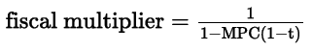

**Balanced budget multiplier:**

Is the difference between the spending increase and the reduction if taxes are reduced by the same amount of the increase. To establish the amount of tax increase that will make the net effect equal to zero, simply divide the spending increase by the MPC.

**Ricardian equivalence**

If taxpayers reduce their consumption and save (because they expected taxes will increase due to a current deficit) just enough to repay the principal and interest on the debt issued to fund a fiscal deficit, there is no effect in aggregate demand.

## Describe the arguments about whether the size of national debt relative to GDP matters

If the real interest rate is higher than the real growth rate, then the debt ratio will increase over time (keeping tax rates constant).

Why be concerned about a fiscal deficit:

* Lead to higher future taxes.
* Market lose confidence in the government, so investors will not refinance their debt.
* Crowding-out effect -> due to government borrowing, interest rate increase and firms reduce their borrowing and investment, decreasing the aggregate demand.

There are some arguments to not be concerned about the fiscal deficit but are really straight forward.

## Explain the implementation of fiscal policy and difficulties of implementation

Discretionary fiscal policy: changes in taxes and spending. When the economy is performing below full employment, it should be expansionary. *The opposite are automatic stabilizers (like regular taxes and spending).

Types of lags that arise from a discretionary policy:

* Recognition lag: Policymaker might take time to make a correct diagnosis of the state of the economy.
* Action lag: Time where the policy is discussed, voted and enacted.
* Impact lag: The time between the enactment and the actual implementation.

These lags can make fiscal policy misleading as they might come to place when the economy is already in another state.

Other factors that might make the policy making usefulness:

* Misreading economic statistics.
* Crowding-out effect of private investment.
* Supply shortages: if an expansionary policy is implemented when the economy is low due to resource constraints, the action will simply generate inflation.
* Limits to deficits.
* Multiple targets: Fiscal policy cannot attack unemployment and inflation at the same time.

## Determine whether a fiscal policy is expansionary or contractionary

The fiscal deficit is a good indicator to check the type of policy that is being implemented. When there is surplus (increase in revenues), it can be concluded that a contractionary policy is implemented.

Structural budget (or cyclically adjusted) deficit: used to check the type of policy. It takes the current policies and determines the deficit if the economy was in full employment.

## Explain the interaction of monetary and fiscal policy

Possible scenarios:

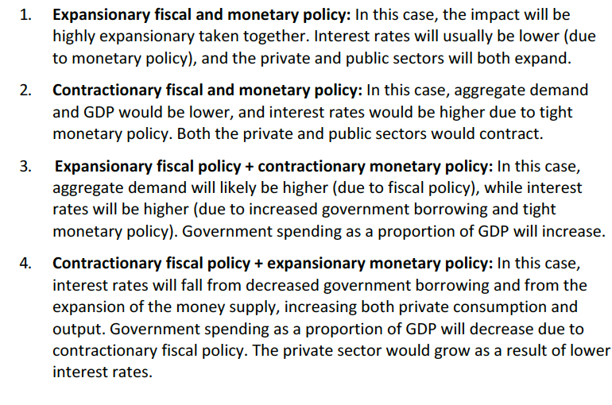

# Reading 20: International trade and capital flows

Important concepts:

Autarky or closed economy: country that does not trade with other countries.

Trade protection: when some restrictions are established.

World price: The price of a good in world markets for those to whom trade is not restricted.

Terms of trade: ratio of an index of exports prices to an index of the prices of its prices (both indexes in the must use the same base).

Foreign direct investment: Ownership of productive resources in a foreign country.

## Compare gross domestic product and gross national product

The difference is that the GNP include every bit of income generated by only the people from a country (without taking into account if the income is made inside or outside the country).

## Describe benefits and costs of international trade

Benefits: access to cheaper goods (when importing) and to an increase in employment, wages and profits (when exporting).

Costs: competition between the domestic industries with imported goods.

Overall, benefits are greater than the costs.

## Distinguish between comparative advantage and absolute advantage

Absolute: A country can produce a good at lower costs than another country.

Comparative: A country that has a lower opportunity cost in the production of the good than producing another one.

So, economies can benefit of each other as long as their comparative advantage is based in different goods and should concentrate in the production of the good which presents the lowest opportunity when produced. By doing this, more of both good A and B are going to be available for both economies. Each one concentrates doing what it is best on.

Opportunity costs of producing good A is calculated as B/A and the answer is in terms of B.

Production possibility frontier: shows all the possible combinations that an economy can have when producing good A and B. The slope of the frontier measures the opportunity cost and its variations.

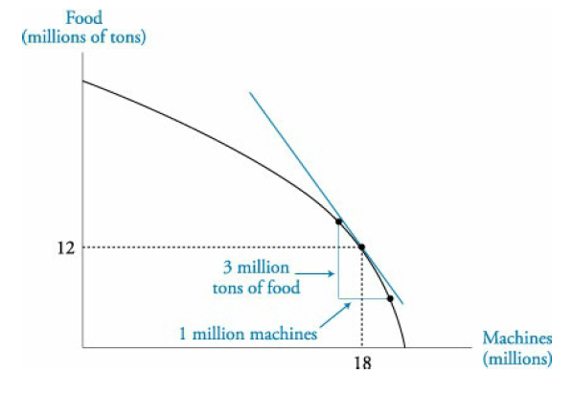

## Compare the Ricardian and Heckscher-Ohlin models of trade and the sources of comparative advantage in each model

Ricardian: Considers only labor, so the difference production costs are in function of labor productivity due to technology.

Hecksher-Ohlin: The source of the comparative advantage considers labor and capital. They state that the country that has more capital should produce the capital intensive good. There would be a redistribution of wealth in the economy since owners of capital will earn more in the country where the capital intensive good is produced.

## Compare types of trade and capital restrictions and their economic implications

Reasons for trade restrictions supported by theory:

* Infant industry: protection to arising domestic industries from foreign competitions.
* National security: it is important to have available certain goods locally in an event of conflict.

Reasons with little support from theory:

* Protecting domestic jobs: Although some jobs will be lost, others will be created on the side of exports and consumers will have access to better priced goods.
* Protecting domestic industries: This is normally driven by political influences from local industries which drive to charging a higher price to consumers.

Other reasons are:

* Retaliation for foreign trade restrictions.
* Collection of tariffs.
* Countering the effects of government subsidies paid to foreign producers.
* Dumping prevention.

Types of restrictions and their economic implications:

* Tariffs: increases the domestic prie, decreases the quantity imported and increases the one supplied domestically. Gains are for the government and domestic producers.
* Quotas: Gains are for the domestic producers but consumer loose when facing higher prices.

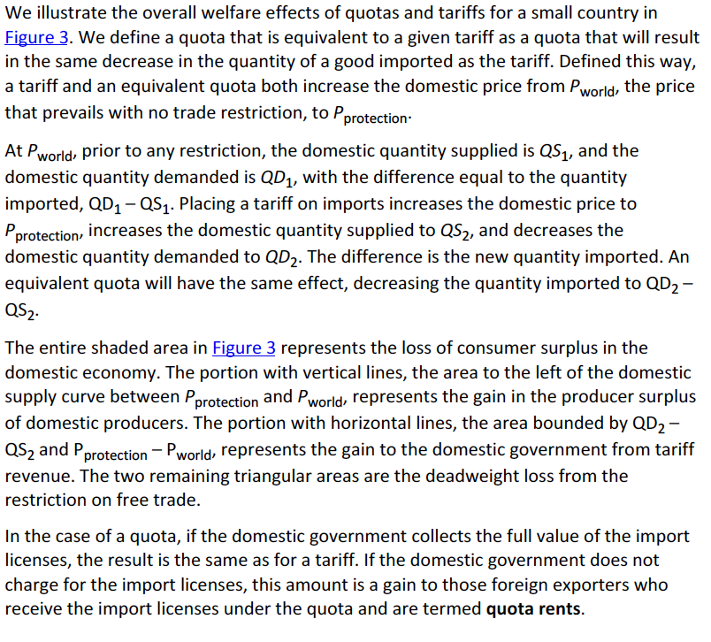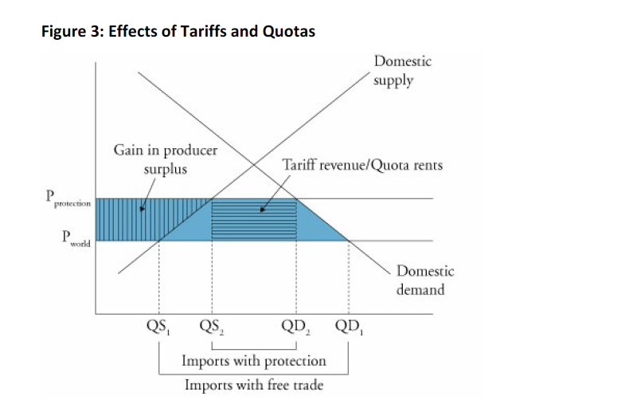

* Export subsidies: If it’s a small producer, the price of the good will increase by the subsidy. If it’s a large exporter, the price decreases.
* Minimum domestic content: minimum percentage of domestic content in the good.
* Voluntary export restraint: this is done under the hopes of avoiding tariffs and quotas from its partners. This will result in a welfare lost to the foreign partner, since the exporter will not be paying as much tariffs and the amount of goods available for the other economy will be less.

In general, the effects are the same for the domestic country:

* Imports reduction.
* Increase price.
* Decrease consumer surplus.
* Increase domestic quantity supplied.
* Increase producer surplus.
* Decrease national welfare (except in some specific cases when imposing tariffs and quotas).

Capital restrictions: Include prohibition of foreign investment, income taxes, among others. Overall, it is believed that these restrictions decrease the welfare. However, in the short term, it protects the country from large capital inflows and outflows of capital.

## Explain motivations for and advantages of trading blocs, common markets and economic unions

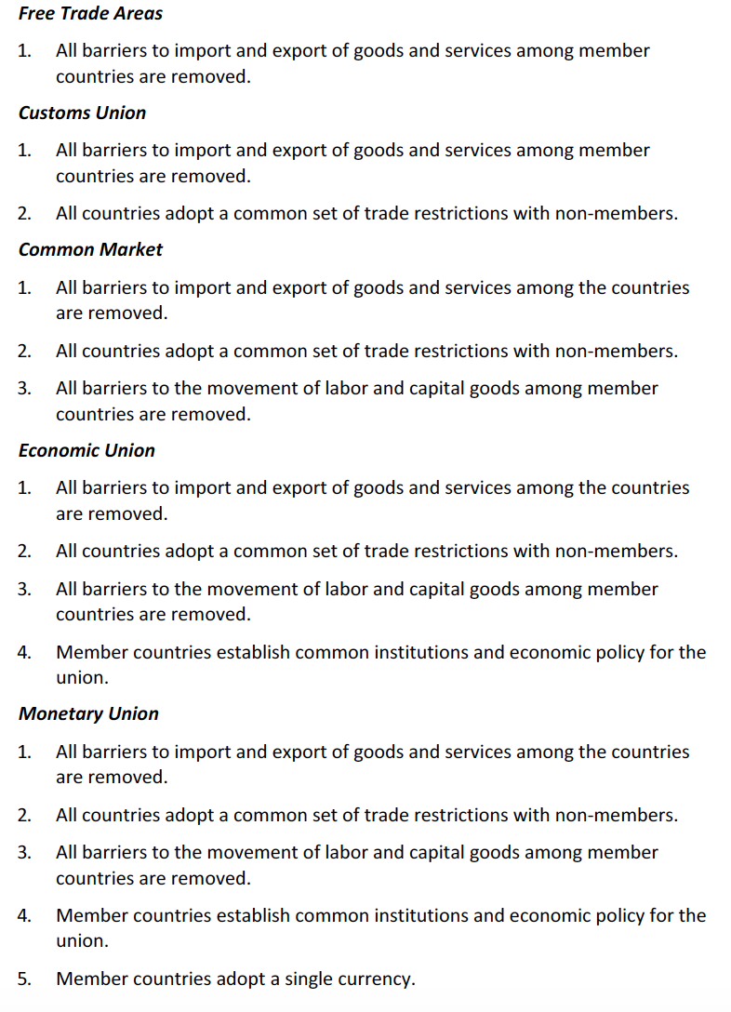

## Describe common objectives of capital restrictions imposed by governments

Restrictions are placed both for inflows and outflows and for locals and foreigners. The objectives are:

* Reduce volatility of domestic asset prices.
* Maintain fixed exchange rates.
* Keep domestic interest rates low (as investors will not be able to pursue higher rates in foreign markets).
* Protect strategic industries.

## Describe the balance of payments accounts including their components

The balance of payments is composed by:

* Current account:
  + Merchandise and services.
  + Income receipts (foreign income from dividends and interest).
  + Unilateral transfers (remittances, donations, one-way transfer of assets).
* Capital account:
  + Capital transfers (assets that are taken in or out when people come or leave the country, purchase or sale of fixed assets…).
  + Sales and purchase of non-financial assets (without including produced assets. This includes intangible assets).
* Financial account:
  + Government-owned assets abroad (gold, foreign currency, securities, credits, direct foreign investment…).
  + Foreign-owned assets in the country (The same but inside the country and owned by foreigners).

When imports > exports, there is a deficit in the current account. This deficit must be balanced with a net surplus in the other accounts (in the form of sales of assets and debt incurred to foreign entities).

## Explain how decisions by consumers, firms and government affect the balance of payments

If savings are less than the amount of investment in domestic capital, the investment must be financed by foreign capital, which implies a surplus in the capital account and a deficit in the current account:



So low savings and an increase in investments will generate a trade deficit. The deficit can be generated also due to consumption. However, this generates a liability with no return as it does in the case of the investment.

## Describe functions and objectives of the international organizations that facilitate trade, including the World Bank, the IMF and the World Trade Organization

IMF:

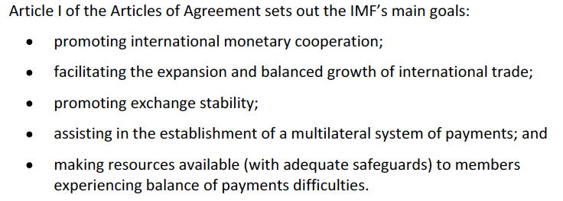

World Bank:



WTO:

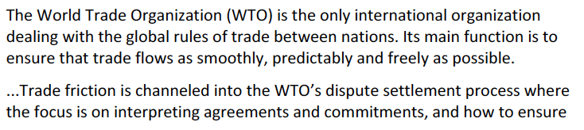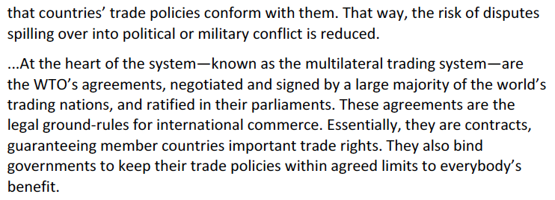

# Reading 21: Currency Exchange Rates

## Define an exchange rate and distinguish between nominal and real exchange rates and spot and forward exchange rates

Assuming the exchange rate 1.25 USD/EUR, USD will be noted as the price currency and EUR as the base currency.

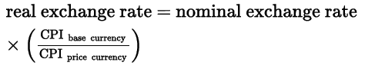

Review what does the real exchange rate actually means and how it is convenient.

Spot exchange rate: the one for immediate delivery. What does it mean that the exchange takes two days after the trade?

Forward exchange rate: Is the currency for exchanges to be done in the future.

## Describe functions of and participants in the foreign exchange market

Hedging: reduce an existing risk.

Speculative: increases risk.

Sell side: large banks.

Buy side: buyers of currencies like:

* Corporations.
* Investment accounts: Real money (without derivatives) and leveraged (with derivatives) accounts.
* Government.
* Retail market (households and small institutions).

## Calculate and interpret the percentage change in a currency relative to another currency

It is simply a percentage change, bearing in mind that when a I have the pair USD/EUR, I will be calculating the appreciation (depreciation) of the EUR relative to the USD and not the other way around.

## Calculate and interpret currency cross-rates

Is the exchange rate between two currencies implied by their exchange rate with a common third currency. To calculated, the common currency must be cancelled when dividing or multiplying the exchange rates.

## Convert forward quotations expressed on a points basis or in percentage terms into an outright forward quotation

Forward exchange rates are usually expressed in terms of the difference with the spot rate.

For a point basis: If the exchange rate has two decimal places and the forward rate is said to be +3.5 points then the forward rate will be 0.035 more than the spot.

For percentage terms: Simply apply the percentage difference.

## Explain the arbitrage relationship between sport rates, forward rates and interest rates

No-arbitrage condition: No opportunity to make profit without any risk.

This condition is met when the percentage difference between the forward and the spot rate equals the difference between the two countries interest rates. Borrow at A interest rate, change to B considering a forward contract to jump back to A and invest it in B interest rate (this will generate a riskless profit if the no-arbitrage condition does not hold).

The interest rate parity will go as follows:

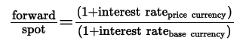

## Calculate and interpret a forward discount or premium

The discount or preium is the percentage difference between the forward price and spot price. Example:

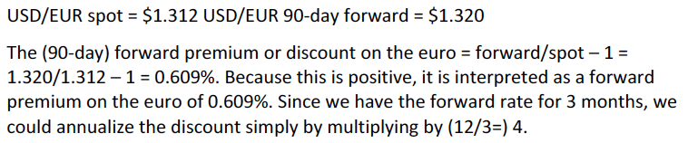

## Calculate and interpret the forward rate consistent with the spot rate and the interest rate in each currency

A currency with a higher interest rate is expected to depreciate over time by approximately the interest rate differential. This happens due to the interest parity that is hold.

An example of arbitrage when the parity is not met:

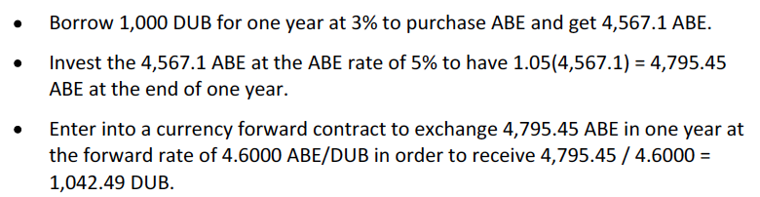

Due to the market behavior, some will pursue the arbitrage opportunity which will level back the interest parity by changing the forward and spot quotations (this could happen by driving up or down either the forward or the spot rate or both).

## Describe exchange rate regimes

**For countries that do not issue their own currency:**

* Formal dollarization: using the currency of another country. The country then cannot have its own monetary policy.
* Monetary union: Local policy can be determined but it is dependent to the central’s Bank policy.

**For countries that have their own currency:**

* Currency board arrangement: A specific arrangement where the domestic currency is exchanged for the foreign currency at a specified rate. Did not understand how they earn interest on their foreign currency balances.
* Conventional fixed peg arrangement: Maintaining a band of +- 1% by purchasing or selling currencies (direct intervention). The change in interest rates and regulation is known as indirect intervention and it is also applied.
* Target zone: The same as the last one but with wider bands.
* Crawling peg:
* Management of exchange rates within crawling bands: The width of the bands is checked over time.
* Managed floating rates: Usage of indirect and direct intervention to maintain a stable interest rate without having an actual target, just responding to indicators as the balance of payments, inflation or employment.
* Independently floating: The rate is market-determined and intervention is simply used to reduce short term fluctuations.

## Explain the effects of exchange rates on countries’ international trade and capital flows

When there is a current deficit, it is because spending and investment is higher than the savings. These deficit (on the right hand) is compensated with a capital account surplus:

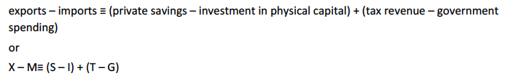

**Elasticities approach:**

Helps understand the effect of exchange rates on the balance of trade, by checking how the changes in exchange rate affect the total expenditures on imports and exports.

Marshall-Lerner condition: where depreciation of the domestic currency decreases the trade deficit:

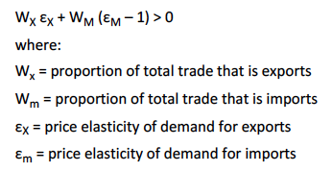

If the goods which are traded are more elastic, then the condition will more likely hold.

The J curve illustrates the actual effect of depreciation. It starts by aggravating the deficit since trade usually tends to suffer the actual effect later on, since payments and transactions of these goods are not usually due immediately:

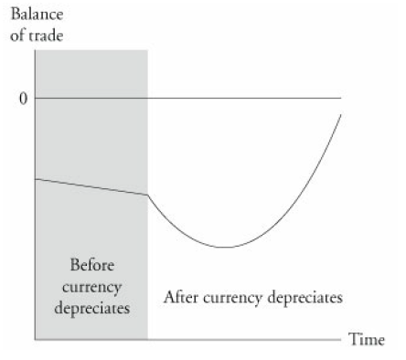

**The absorption approach**

Elasticities does not take into account the changes in capital flows. The absorption approach does and it is represented as:

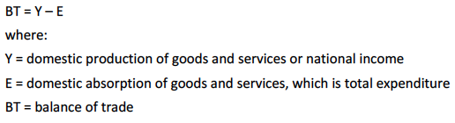

So, for the BT to improve due to a depreciation, domestic absorption must fall, which means that savings must increase, as well as national income.

This only works when the economy is not working at full employment.